MAY – WHERE THINGS MOVE FAST
May is one of the busiest and most important months in the beekeeping year. Colonies that were building steadily through April now accelerate quickly, with large brood nests, increasing populations and strong foraging activity.
This is also the month where things can get out of control if you are not paying attention. Colonies can grow rapidly, fill available space, and begin swarm preparations before you realise it.
The key difference in May is that you are no longer preparing — you are actively managing.
WEATHER, TEMPERATURE & SEASONAL CONDITIONS
May generally brings warmer, more stable conditions, but it is still not completely predictable. Periods of strong foraging can be followed by poor weather that shuts colonies down temporarily.
Warmer temperatures allow colonies to expand quickly, and brood rearing increases significantly. However, this also increases demand for food and space, and it shortens the time you have to react to changes.
Unlike April, inspections are more frequent in May, but they still need to be based on conditions. Warm, calm days are ideal, while poor weather should still be avoided where possible.
The key thing to understand is that May speeds everything up. Colonies change faster, and your timing becomes more important.

REALITY CHECK: In May, a colony can go from “fine” to “swarming” in a week.

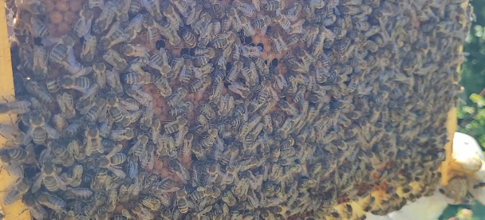
WHAT YOUR BEES ARE DOING
By May, colonies are at full expansion. You should expect large areas of brood, increasing drone populations, and a strong foraging force working available nectar flows such as oilseed rape, fruit blossom and hedgerow plants.
This rapid growth creates pressure inside the hive. The colony is trying to expand, store nectar and reproduce at the same time.
That combination is what drives swarming.
Understanding that this is natural behaviour helps you manage it rather than react to it.
INSPECTIONS – STAYING AHEAD
In May, inspections become your main control tool.
They should be carried out roughly every 7 days when conditions allow, but the key is not just frequency — it is what you are looking for.
Each inspection is focused on confirming that the colony is queenright, assessing brood quality, and most importantly, identifying any signs of swarm preparation. Queen cells can appear quickly, and missing them even once can result in losing a swarm.
At the same time, you need to assess space within the hive. Colonies that feel congested are far more likely to swarm, so recognising early signs of crowding is essential.
Inspections should remain controlled and efficient. Even though the weather is warmer, unnecessary disturbance still slows colonies down.

PRACTILE RULE: If you’re not looking for queen cells properly in May, you’re not really inspecting.

SWARM CONTROL – THE MAIN PRIORITY
May is peak swarm season.
At this stage, you are not just watching for swarming — you should be expecting it and managing it.
Strong colonies, particularly those with older queens, will attempt to swarm if conditions are right. Your role is to identify these colonies early and act before they do.
Swarm control should not be improvised. Whether you are using artificial swarm methods, splits or nucleus creation, you should already understand your chosen method and have the equipment ready.
If queen cells are found, the key is to stay calm and follow your method properly. Panic or rushed decisions often make the situation worse.

REALITY CHECK: If you’re reacting to swarm cells, you’re already behind. The goal is to stay ahead of them.

SPACE MANAGEMENT & SUPERING
In May, space becomes critical.
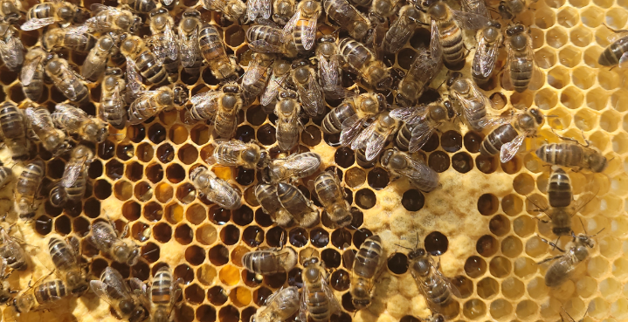
During strong nectar flows, colonies can fill a super very quickly, sometimes within a week. If space is not provided at the right time, congestion builds and swarm pressure increases.
Supers should be added based on what the colony is doing, not on fixed timing. If bees are working most brood frames and bringing in nectar steadily, it is time to give them more room.
Drawn comb is ideal, but strong colonies will draw foundation when conditions are right.
Monitoring how quickly supers fill also gives you a good indication of how strong the current nectar flow is.
COMB REPLACEMENT & FRAME MANAGEMENT
May is a practical time to continue replacing old brood frames and improving comb quality.
Older frames, particularly those that are dark or damaged, should be gradually removed and replaced. This helps reduce disease risk and keeps the brood nest healthy.
If you have drawn brood frames available, this becomes much easier. If not, May is a good time to start building up drawn comb by allowing bees to work foundation in strong colonies.
Care should be taken not to remove too much brood or stores at once, as this can set the colony back.
EQUIPMENT & APIARY MANAGEMENT
By May, your equipment needs to be fully ready.
This includes having spare brood boxes, supers, frames and feeders available, as well as everything required for swarm control. If you need equipment and don’t have it ready, you will struggle to manage colonies effectively.
The apiary itself should also be maintained. Grass and vegetation should be controlled to improve access and reduce damp conditions. Clear working space around hives makes inspections easier and safer.
Water sources should be available nearby, as bees require water for cooling the hive and processing nectar.
Swarm traps or bait hives should already be in place if you intend to use them.
QUEEN PERFORMANCE & POSSIBLE REARING
May is one of the best times to assess queen performance.
Strong, productive colonies with calm behaviour and solid brood patterns stand out clearly during this period. These are the colonies you may want to keep, breed from or use for future queen rearing.
Equally, colonies that are consistently aggressive or underperforming become more obvious and can be marked for future requeening.
If you are interested in queen rearing, May provides suitable conditions for mating flights, and this is often when people begin exploring it.
FOOD & STORES – STILL IMPORTANT
Although May often brings strong nectar flows, food should not be ignored.
Rapid colony growth means consumption remains high, and a sudden change in weather or the end of a nectar flow can leave colonies short very quickly.
Regular checks of stores, along with simply being aware of colony weight, help prevent unexpected problems.
RECORD KEEPING – MORE IMPORTANT THAN EVER
May can feel busy, and this is exactly when records matter most.
Keeping track of inspections, queen cells, swarm control actions and super additions allows you to stay organised and understand what is happening in each colony.
Without records, it becomes much harder to follow what you have done and what needs to happen next.

MAY APIARY CHECKLIST
Use this at every inspection to stay consistent and avoid missing key steps.
☐ Observed entrance activity and foraging
☐ Confirmed presence of eggs or young larvae
☐ Assessed brood pattern and colony strength
☐ Checked carefully for queen cells
☐ Assessed congestion and available space
☐ Added supers where required
☐ Checked nectar flow progress
☐ Replaced or identified old/damaged frames
☐ Confirmed water source availability
☐ Checked for signs of disease or abnormal behaviour
☐ Ensured equipment is ready for swarm control
☐ Maintained apiary (grass, access, hive stability)
☐ Set or checked swarm traps if used
☐ Recorded inspection details and actions taken
HOW THE MONTH PROGRESSES
Early May often continues the build-up from April, with increasing brood and steady expansion.
Mid-May is typically when swarm pressure peaks, particularly in strong colonies, and when most beekeepers are actively managing swarm control.
Late May can bring heavy nectar flows in good years, but also rapid changes if those flows end suddenly.
Understanding how the month progresses helps you anticipate what is coming rather than reacting to it.
FINAL WORD
May is where beekeeping becomes hands-on.
If you stay consistent with inspections, manage space properly and stay ahead of swarm pressure, your colonies will thrive. If you fall behind, things can unravel quickly.
If you only focus on one thing in May, make sure you stay ahead of your strongest colonies. That is where most problems start.

